**4.3 System Analysis**

**4.3 1 Usecase diagram for Jiinue Youth Sacco**

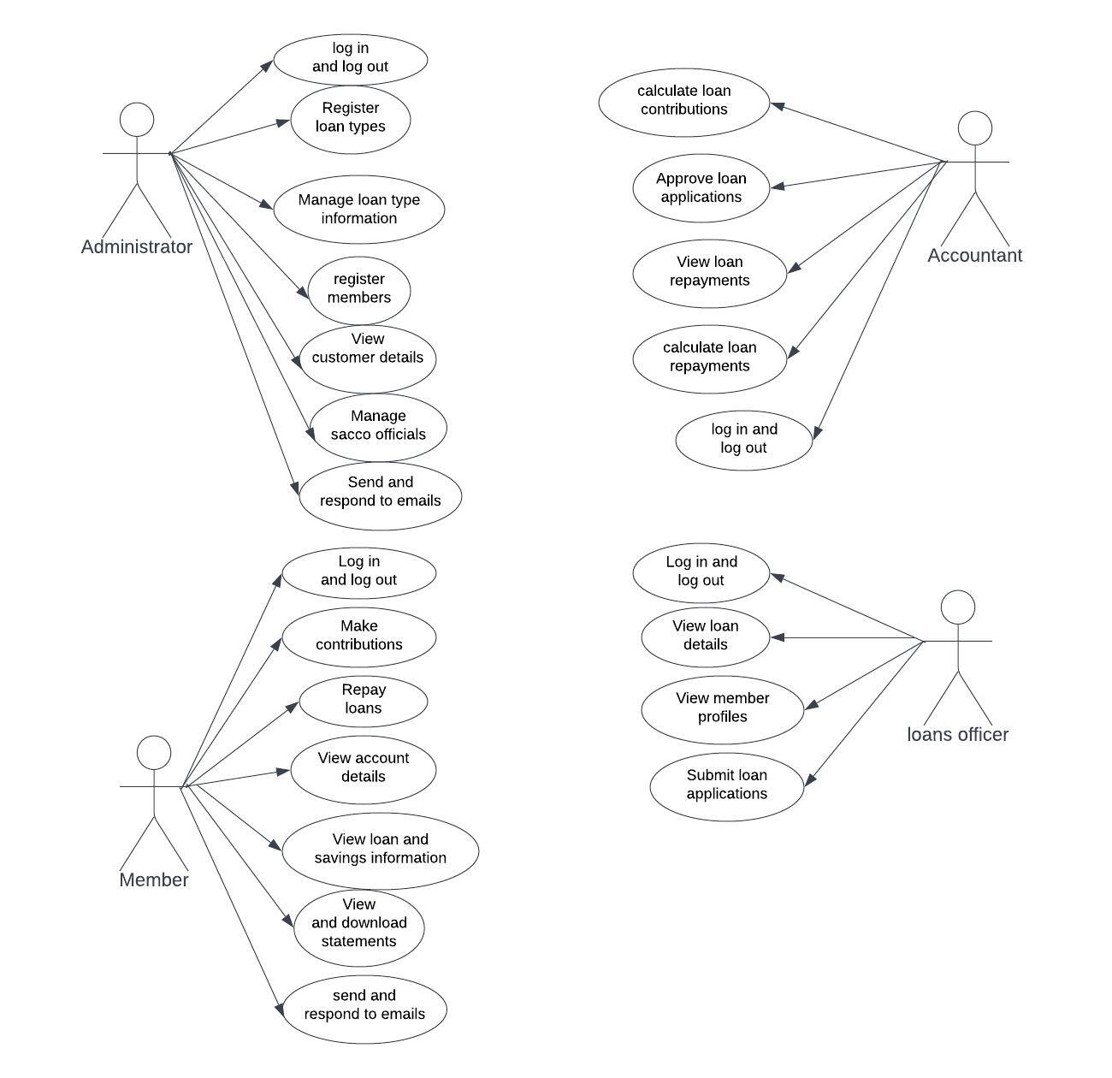

**4.3 2 Activity diagrams**

**1) Sacco member**

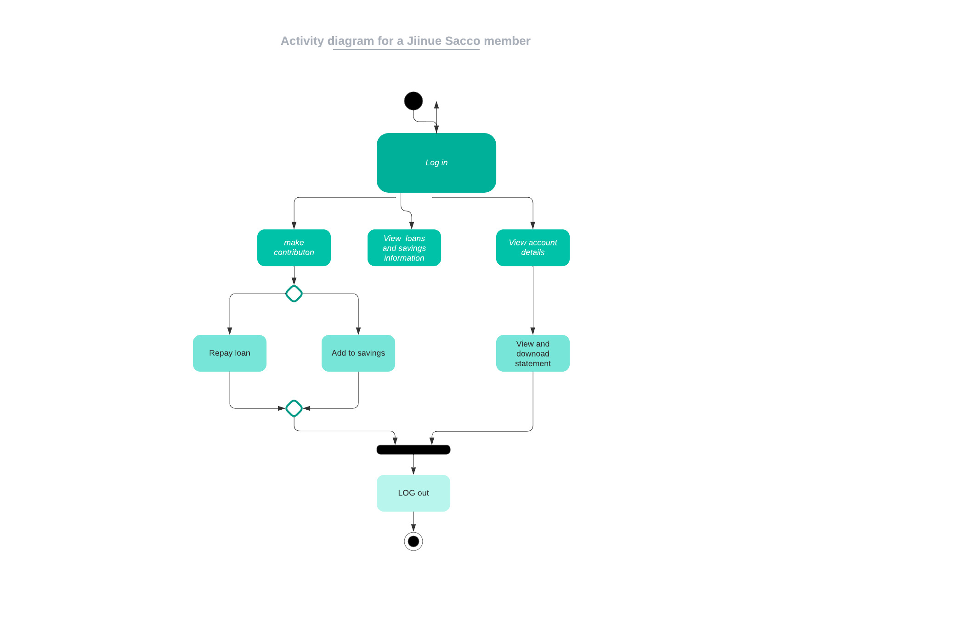

**2) Sacco Administrator**

